Course Name: | Object Oriented Programming Methodology | Semester: | III
Date of Performance: |  | Batch No: | A2
Faculty Name: | Prof. Kavita Kelkar | Roll No: | 16010122034
Faculty Sign & Date: |  | Grade/Marks: | ___/25

Experiment No: 6
Title: Case Study ( Class Diagram )

Aim and Objective of the Experiment:
Draw class Diagram for the chosen Case Study. Clearly show
  - Attributes
  - Multiplicities between classes
  - Aggregations/compositions/Association between classes
  - Generalization between classes in the class diagram.
And show the implementation of aggregation, association, composition and generalization between the classes.

COs to be achieved:
CO1: Understand the features of object oriented programming compared with procedural approach with C++ and Java.
CO2: Explore arrays, vectors, classes and objects in C++ and Java.
CO3: Implement scenarios using object oriented concepts (Drawing class diagram, relationship between classes, sequence diagram)
CO4: Explore the interface, exceptions, multithreading, packages

Tools used:
JDK, VScode / Eclipse

Theory:
Pre Lab/ Prior Concepts:

Define Class, Methods and Object.

A class in Java is a set of objects which shares common characteristics/ behavior and common properties/ attributes. It is a user-defined blueprint or prototype from which objects are created.

Properties of Java Classes:
- Class is not a real-world entity. It is just a template or blueprint or prototype from which objects are created.
- Class does not occupy memory.
- Class is a group of variables of different data types and a group of methods.
- A Class in Java can contain:
  - Data member
  - Method
  - Constructor
  - Nested Class
  - Interface
The method in Java or Methods of Java is a collection of statements that perform some specific task and return the result to the caller. A Java method can perform some specific task without returning anything. Java Methods allow us to reuse the code without retyping the code. In Java, every method must be part of some class that is different from languages like C, C++, and Python.
1. A method is like a function i.e. used to expose the behavior of an object.
2. It is a set of codes that perform a particular task.
An object in Java is a basic unit of Object-Oriented Programming and represents real-life entities. Objects are the instances of a class that are created to use the attributes and methods of a class. A typical Java program creates many objects, which as you know, interact by invoking methods. An object consists of :
- State: It is represented by attributes of an object. It also reflects the properties of an object.
- Behavior: It is represented by the methods of an object. It also reflects the response of an object with other objects.
- Identity: It gives a unique name to an object and enables one object to interact with other objects.

Understanding of Aggregation, Association, Composition and Generalization between classes

Aggregation: The relationship between the whole and part, and the whole and part can be separated.

Aggregate relations also represent the relationship between the whole and part of the class, member objects are part of the overall object, but the member object can exist independently from the overall object.
For example, bus drivers and work clothes and hats are part of the overall relationship, but they can be separated. Work clothes and hats can be worn on other drivers. Bus drivers can also wear other work clothes and hats.
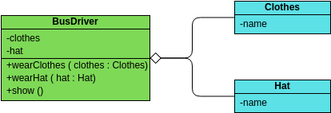

Association: Indicates that a property of a class holds a reference to an instance (or instances) of another class.

Association is the most commonly used relationship between a class and a class, which means that there is a connection between one type of object and another type of object. Combinations and aggregations also belong to associative relations , but relations between classes of affiliations are weaker than the other two.

There are four kinds of associations : two-way associations , one-way associations , self-association , and multiple-number associations .

For example: cars and drivers, one car corresponds to a particular driver, and one driver can drive multiple cars.

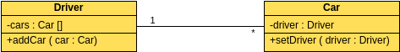

Composition: The relationship between the whole and the part, but the whole and the part cannot be separated .
The combination relationship represents the relationship between the whole and part of the class, and the overall and part have a consistent lifetime. Once the overall object does not exist, some of the objects will not exist, and they will all die in the same life. For example, a person is composed of a head and a body. The two are inseparable and coexist.
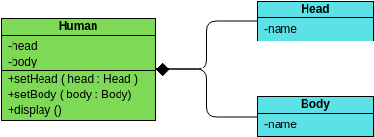

Generalization is used to describe the relationship between parent and child classes. A parent class is also called a base class, and a subclass is also called a derived class.

In the inheritance relationship, the subclass inherits all the functions of the parent class, and the parent class has all the attributes, methods, and subclasses. Subclasses contain additional information in addition to the same information as the parent class.

For example: buses, taxis, and cars are cars, they all have names, and they can all be on the road.
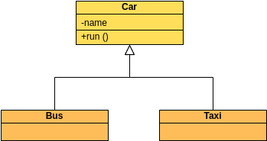

List Of Classes:

Atm
AtmTransaction
Account
Customer
CurrentAccount
SavingAccount

Identify Attributes for each class:

Atm : transactions, customerList
AtmTransaction : transactionId, cardNumber, transactionType,amount
Account : accountNumber, balance
Customer : name, cardNumber, pin, current, saving, accountType
CurrentAccount : type
SavingAccount : type

Identify List of Methods in each classes:

Atm : transact, viewBalance, listTransactions
AtmTransaction : display
Account : deposit, getAccountNumber, getBalance
Customer : verifyPin
CurrentAccount : withdraw
SavingAccount : withdraw

Class Diagram:
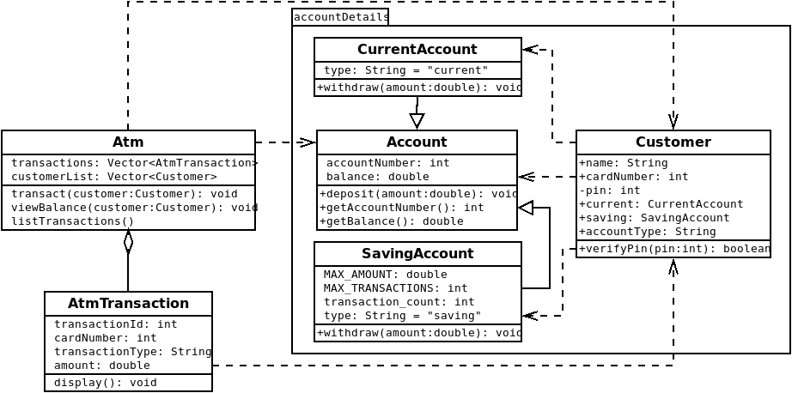

Algorithm:
Step 1: Start
Step 2: Input the card number and pin from the user.
Step 3: Verify the card number and PIN inputted with the pre-existing list of customers.
Step 4: If the user’s details are not correct then prompt the user about the same and go to Step 2
Step 5: Check if the user is the admin. If they are, then display the details of all transactions to them and ask to shutdown the ATM. If the admin wishes to shut it down, then End else go to Step 2.
Step 6: Input the next action from the user: transact or display balance.
Step 7: If the user wishes to see their balance, then display the amount in their account.
Step 8: If the user wishes to transact, take input from the user about the kind of transaction they wish to do: withdrawal or deposit.
Step 9: If the user wishes to deposit money, input the amount being deposited and increment their balance by that amount.
Step 10: If the user wishes to withdraw money, ask them the amount to be withdrawn. If the user’s account is a current account, then let the user withdraw the inputted amount and reduce the balance accordingly. If the user’s account is a savings account, then check if the amount to be withdrawn exceeds the preset limit on the account and also check if the maximum number of daily transactions has not been lapsed. If none of these two are the case, then let the user withdraw the amount, reduce the balance of the account accordingly and increment the daily number of transactions being made. If either one of these cases are met, prompt the user about the same.
Step : Go to Step 2
Step : End

Code:
File Structure:
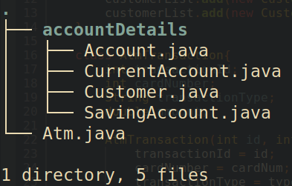

Account:
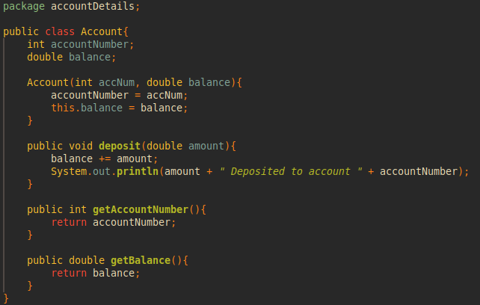

CurrentAccount:
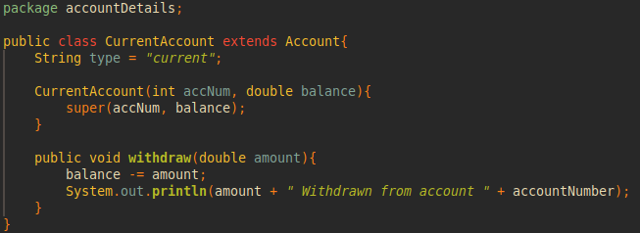

SavingAccount:
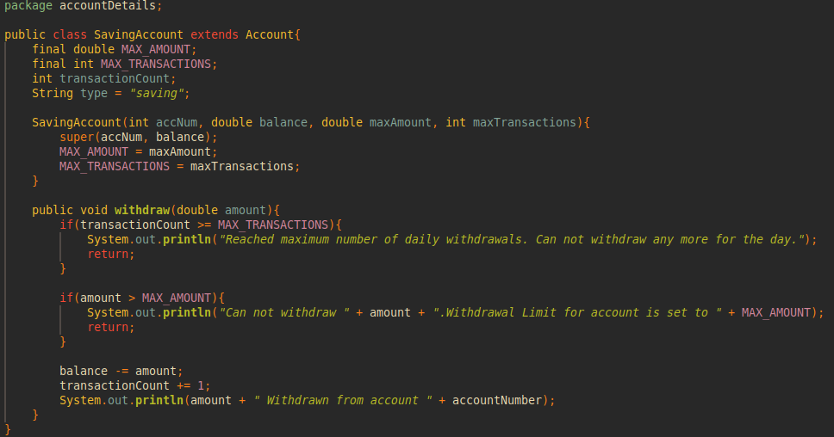

Customer:
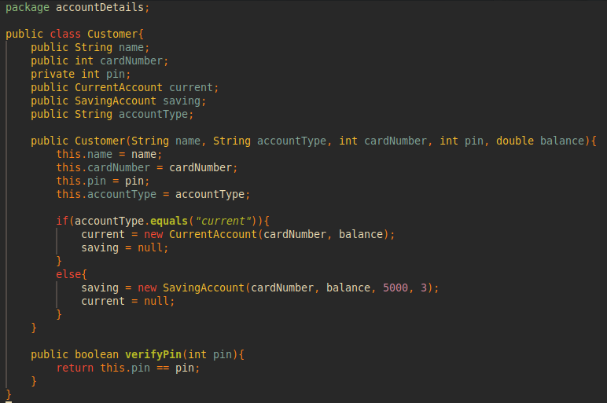

Atm:
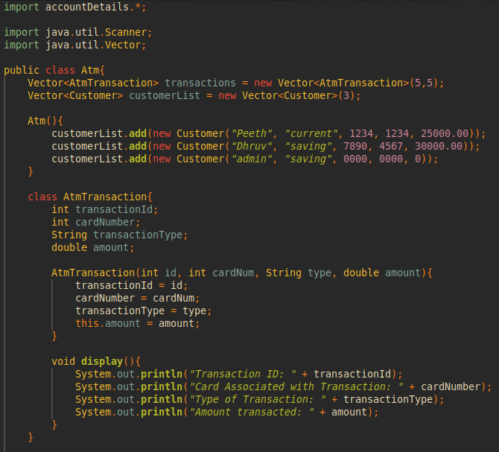
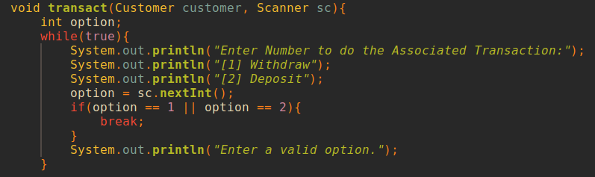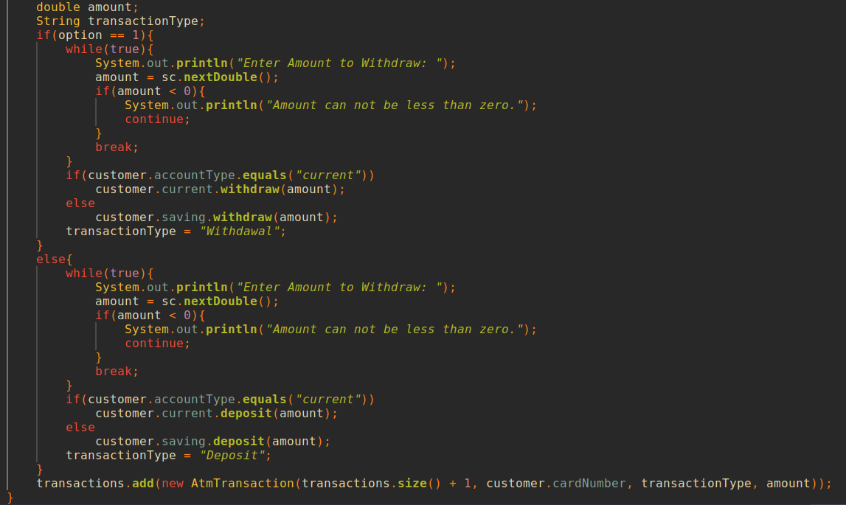
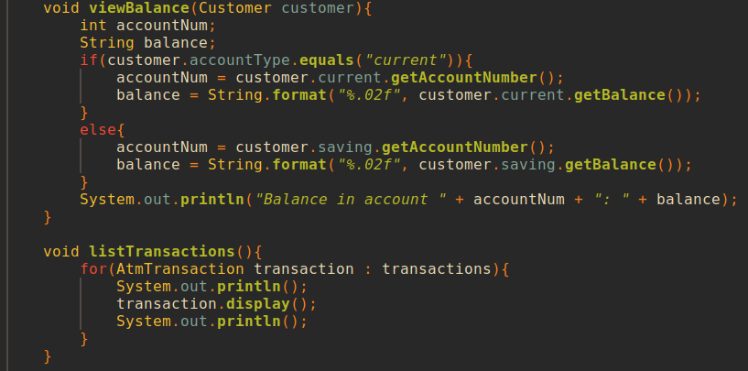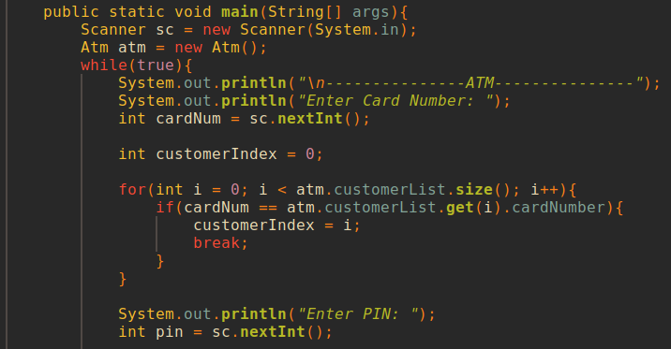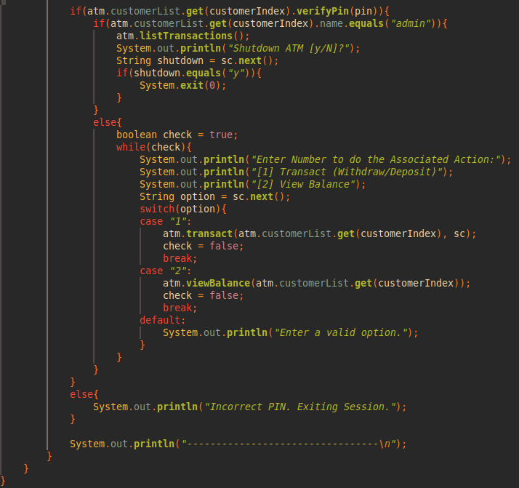

Outputs:
All test cases show that the implementation works as intended

- Able to withdraw any amount from current accounts:
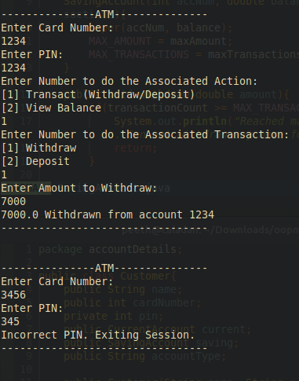

- Entering an incorrect PIN:


- Unable to withdraw over a set limit (5000) from a savings account:
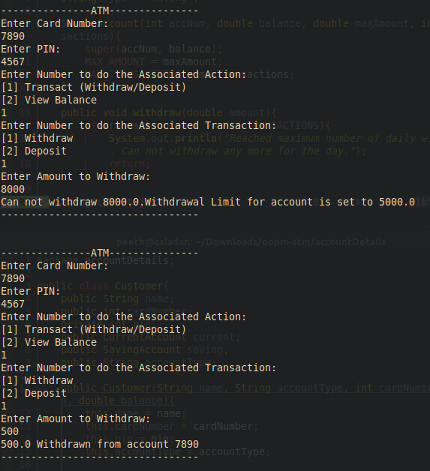

- Unable to withdraw from a saving account more than thrice:


[ 5) Program asks for valid input at each step related to the user deciding which action to take:]
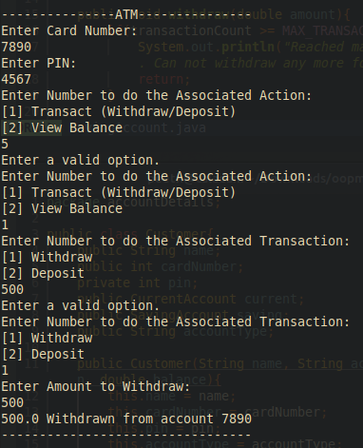
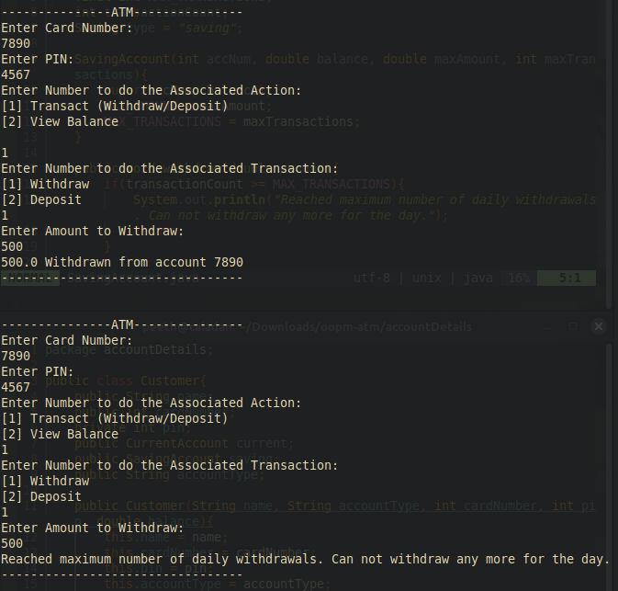
Above is the desired output for Test 4
6) Balance is displayed correctly after the above transactions: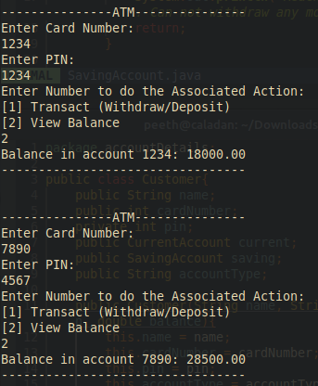

7) Admin gets a record of all transactions at this ATM and an option to shut it down (exit program):
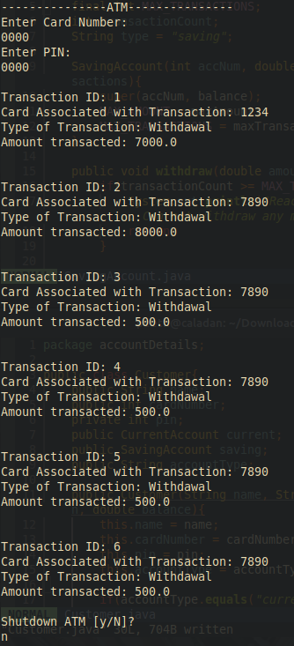

8) If Admin opts to Shutdown the ATM, then the program ends:
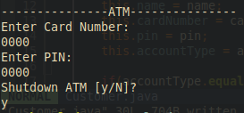

9) Balance also update properly after deposits (25000 + 3000 = 28000):
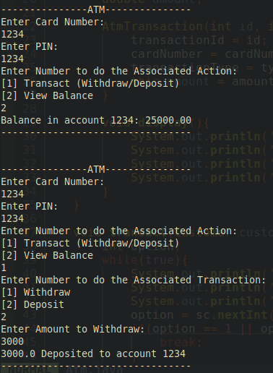
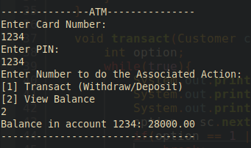

Post Lab Subjective/Objective type Questions:
1. Consider the following class:
public class TypeOfVariable{
public static int a;
int b,c;
public void printValue(){
int x = 10;
}
public static void main(String args[]){
TypeOfVariable object=new TypeOfVariable();
object.printValue();
}
}
- What are the class/static variables?
‘a’ is a class variable.

- What are the instance variables?
‘b’ and ‘c’ are instance variables

- What are local variables?
‘x’ is a local variable in the printValue method and ‘object’ is a local variable in the main method.

2. What is the output from the following code:
public class Test
{
static int x = 11;
private int y = 33;
public void method1(int x)
{
Test t = new Test();
this.x = 22;
y = 44;

System.out.println("Test.x: " + Test.x);
System.out.println("t.x: " + t.x);
System.out.println("t.y: " + t.y);
System.out.println("y: " + y);
}

public static void main(String args[])
{
Test t = new Test();
t.method1(5);
}
}

Output:
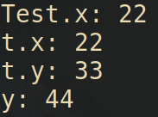

Conclusion:
A well-designed library management program offers numerous benefits to both library staff and patrons. It allows librarians to manage their collections effectively, track inventory, and offer a range of services to their patrons. Furthermore, it enhances the overall library experience for users by providing easy access to resources, cataloging, and self-checkout options.
In conclusion, this code serves as a simple library catalog management system, and it can be used for educational purposes to understand Java programming concepts such as custom exceptions, regular expressions, user input validation, and class interactions. When presenting this code, you can highlight its modularity and error-handling capabilities, making it a useful tool for library management.

Signature of faculty in-charge with Date:

